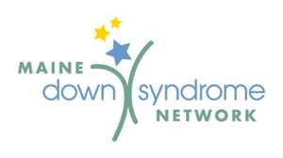

Third Party Fundraiser Proposal

Thank you for your interest in raising funds for Maine Down Syndrome Network (MDSN). We are grateful to have you support the organization in our mission of promoting awareness and acceptance of people with Down syndrome by offering support, education and advocacy to our members, and to our communities.

The Board of Directors has developed the following guidelines pertaining to fundraising events to benefit MDSN that are sponsored by third parties (individuals or organizations other than MDSN) and it’s Board.

- The Board of Directors respectfully requests that all individuals or organizations wishing to host a fundraiser to benefit MDSN to complete a Third Party Fundraiser Proposal prior to the event.
- MDSN will notify the applicant of the status of your fundraiser proposal within 30 days of receiving it.
- The Board requests that all proceeds and a final income/expense report, including all receipts, be submitted to MDSN within 30 days following the event.
- Third parties are prohibited from establishing bank accounts in MDSN’s name in conjunction with a fundraiser.

MDSN is pleased to assist you in planning your fundraiser by offering the following:

- Permission to use MDSN name and logo for the event.
- Advertising on MDSN website, member forum, facebook page, twitter account, as space and time permit.
- MDSN informational materials
- Guidance/suggestions with event planning.

I understand MDSN’s guidelines for third party fundraising and agree to abide by them.

Signature: _____________________________Date:______

Printed Name: ____________________________________

